**MEMO**

**TO:** Michael E Whittenberg

**TEAM:** 14

**SUBJECT:** DELIVERABLE 3

**Scope:**

The objective of this project is to build a well-defined, highly precise, and cost effective computer controlled conveyor belt system for future installations. The newly developed conveyor system is expected to replace the existing system and be flexible enough to incorporate any future technical advancements.

The Risk Assessment Matrix, Risk Response Matrix and Budget, and Management Reserves are attached as appendices below. It also includes the Gantt chart after levelling within the slack and outside the slack in the appendices.

**Part A:**

1. Without resource levelling there are three resources with over allocation: Design, Development and Documentation.

2. The Gantt chart with the schedule table after levelling within slack is attached as appendix.   
When the project is time constrained, the number of critical activities goes up and over allocation of resource **development** is still present. The over allocation problem with the “Documentation” team is resolved without moving the end date of our project, but it cannot be resolved with the “Development” team in many dates of the project. The changes in start and finish dates of activities can be seen in blue in the software.

3. Since the number of critical activities increases and slack time is reduced, the sensitivity of the network also increases.

4. Gantt chart with the schedule table after levelling outside of slack is included as appendix.   
When the over allocation is resolved by levelling outside of slack i.e. the project is resource constrained, the number of days for completion of the project rises to 675 days. This will increase the need for more resources to complete the project, which implies increase in the overall budget of the project. This increase needs to be communicated to the senior management by the project manager.   
After assigning additional resources, the task can be completed in 530 days.

5. Since the project priority matrix indicates that our constraint is the time of the project, the available option would be adding more resources to complete the project on time and accept additional costs.

**PART B:**

1. Addition of two additional development teams which costs $57,600 i.e. the cost allocated for routine utilities for which the external development team has been assigned. Also assuming that two additional teams will be sufficient to get the job done by Feb 2, 2012 and we do need one other development team from outside. The critical path remains same.
2. The project takes 530 days to complete after adding the 2 additional teams.
3. The changes do-not affect the sensitivity since the critical path remains the same.

**MANAGEMENT & CONTINGENCY RESERVES:**

Contingency Reserves – An amount of money or time set aside to cover identified and unforeseen project risks. There is a great likelihood that the project will be impacted by unforeseen Resource Constraints. Therefore, for the current total budget of $1,027,200 the Contingency Reserves are projected to be $188,320.

Budget Reserves – Reserve setup to cover identified risks that may occur and influence baseline tasks or costs. These reserves are typically controlled by the project manager and the project team.

Identified Risks that may occur:

Incorrect Hardware Specifications – Total cost to redo $68,000

Incorrect Kernel Specifications – Total cost to redo $16,000

Circuit Board Order Delayed – Total cost to reorder $1,600

Total Budget Reserves = $85,600

Management Reserves – A percentage of the total project budget reserved for contingencies. The fund exists to cover unforeseen, new problems – not necessary overruns. The reserve is designed to reduce risk of project delays. Management reserves are typically controlled by the project owner or project manager.

The current cost of the project leveled within slack is currently $1,027,200. Ten percent of the current budget will be added for Management Reserves totaling $102,720.

Appendix A

**GANT CHART BEFORE LEVELLING:**

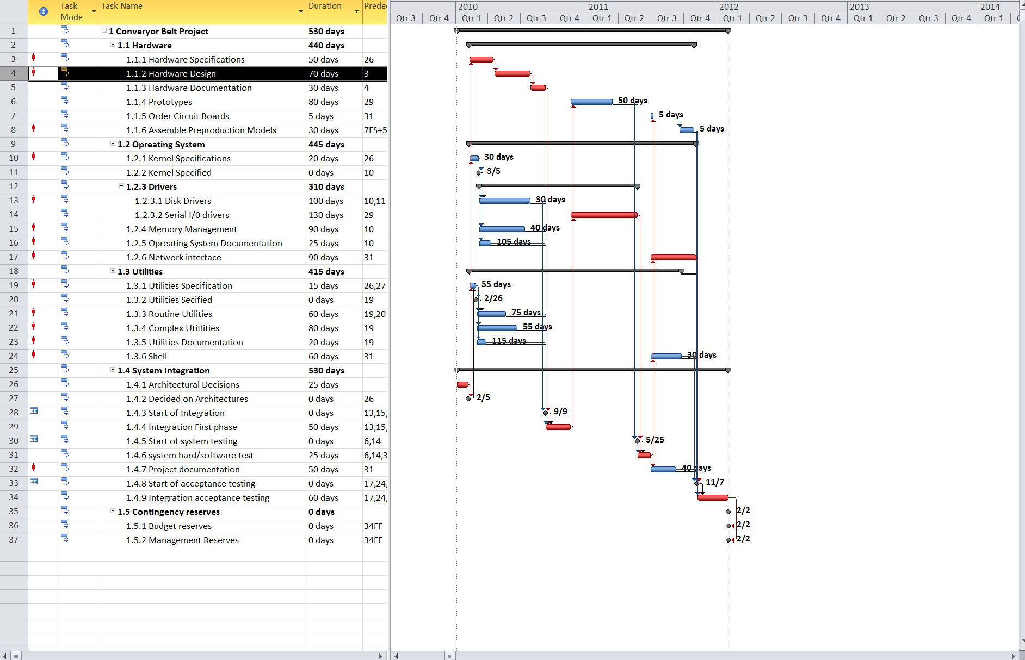

Appendix B

**NETWORK DIAGRAM WITH MILESTONES**

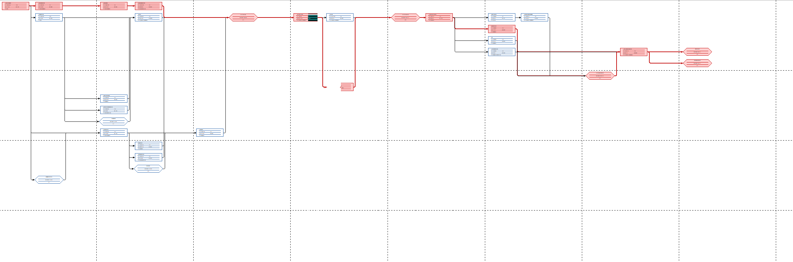

Appendix c

**RESOURCES BEFORE LEVELLING:**

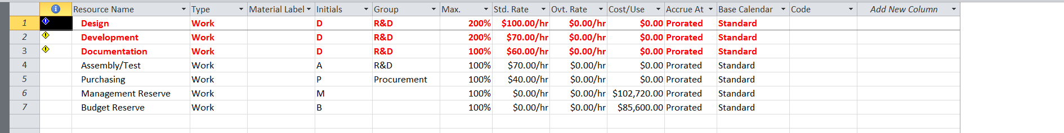

Appendix D

**GANT CHART LEVELLING WITHIN SLACK:**

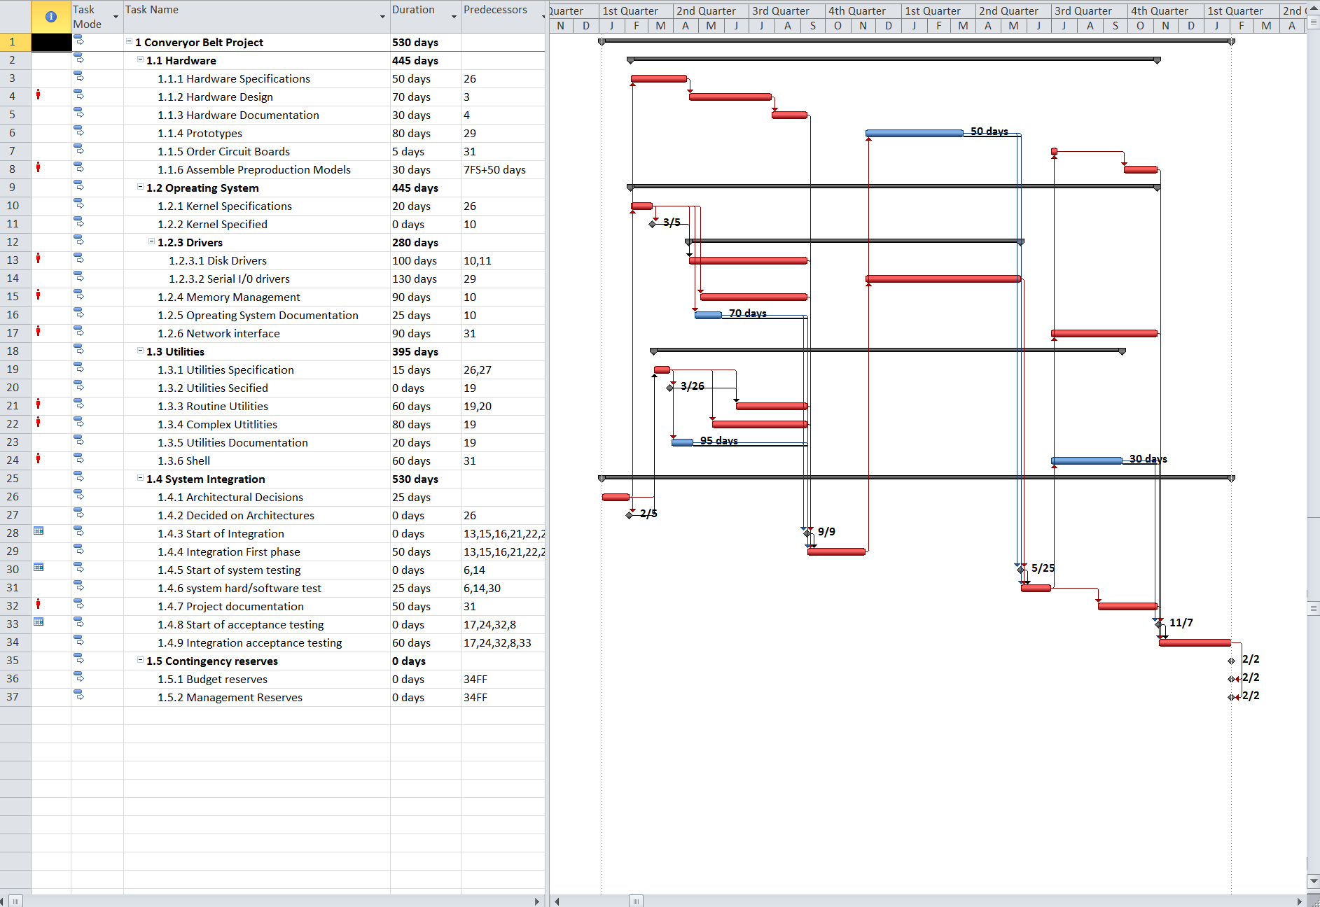

Appendix E

**SCHEDULE LEVELLING WITHIN SLACK:**

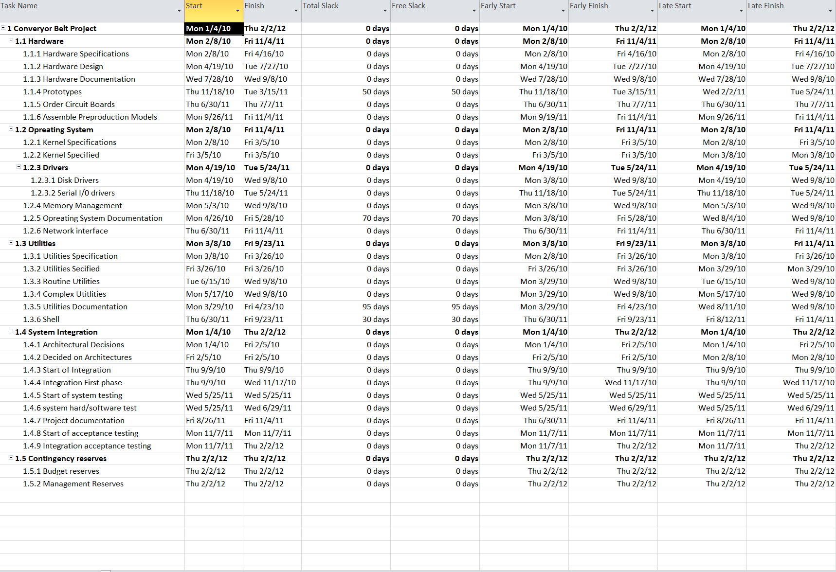

Appendix F

**GANT CHART LEVELLING OUTSIDE SLACK:**

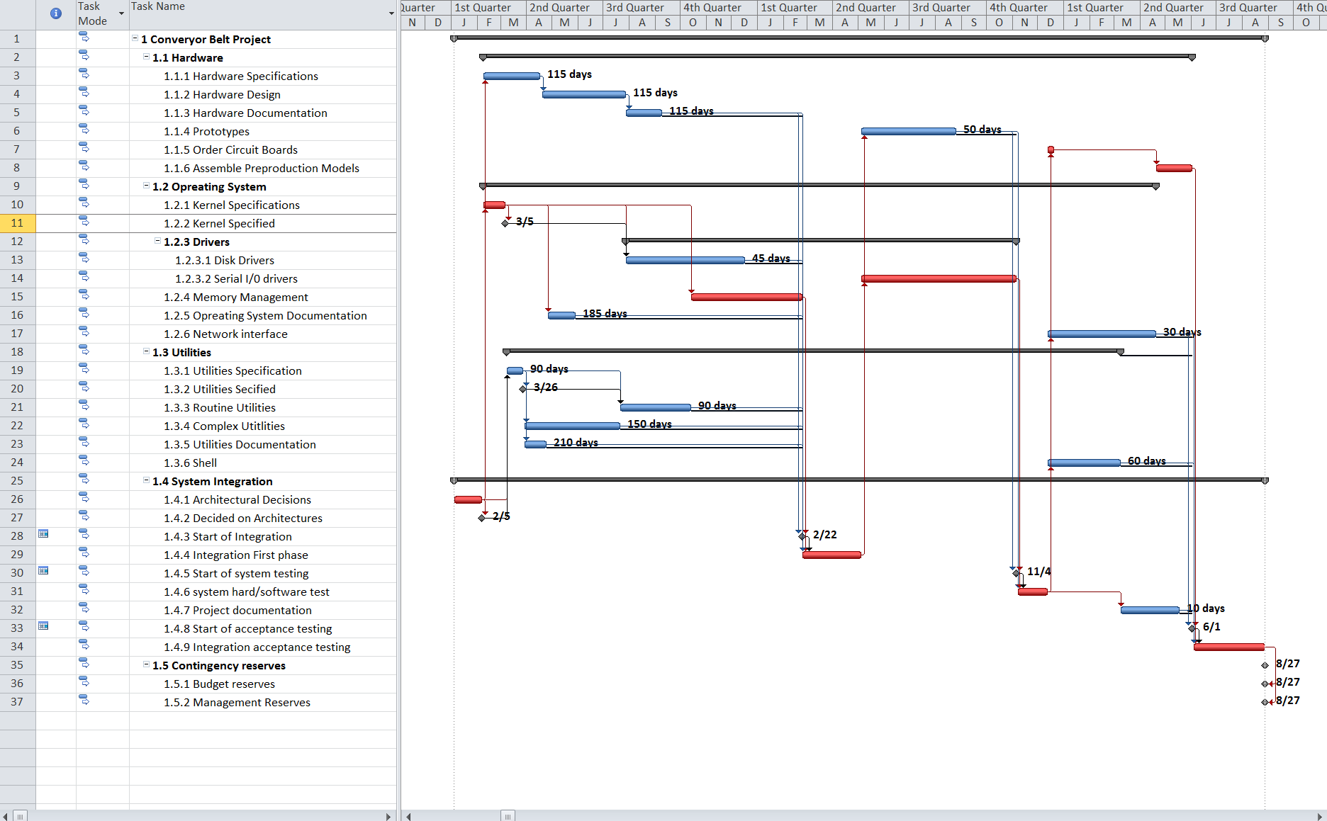

Appendix G

**SCHEDULE LEVELLING OUTSIDE SLACK:**

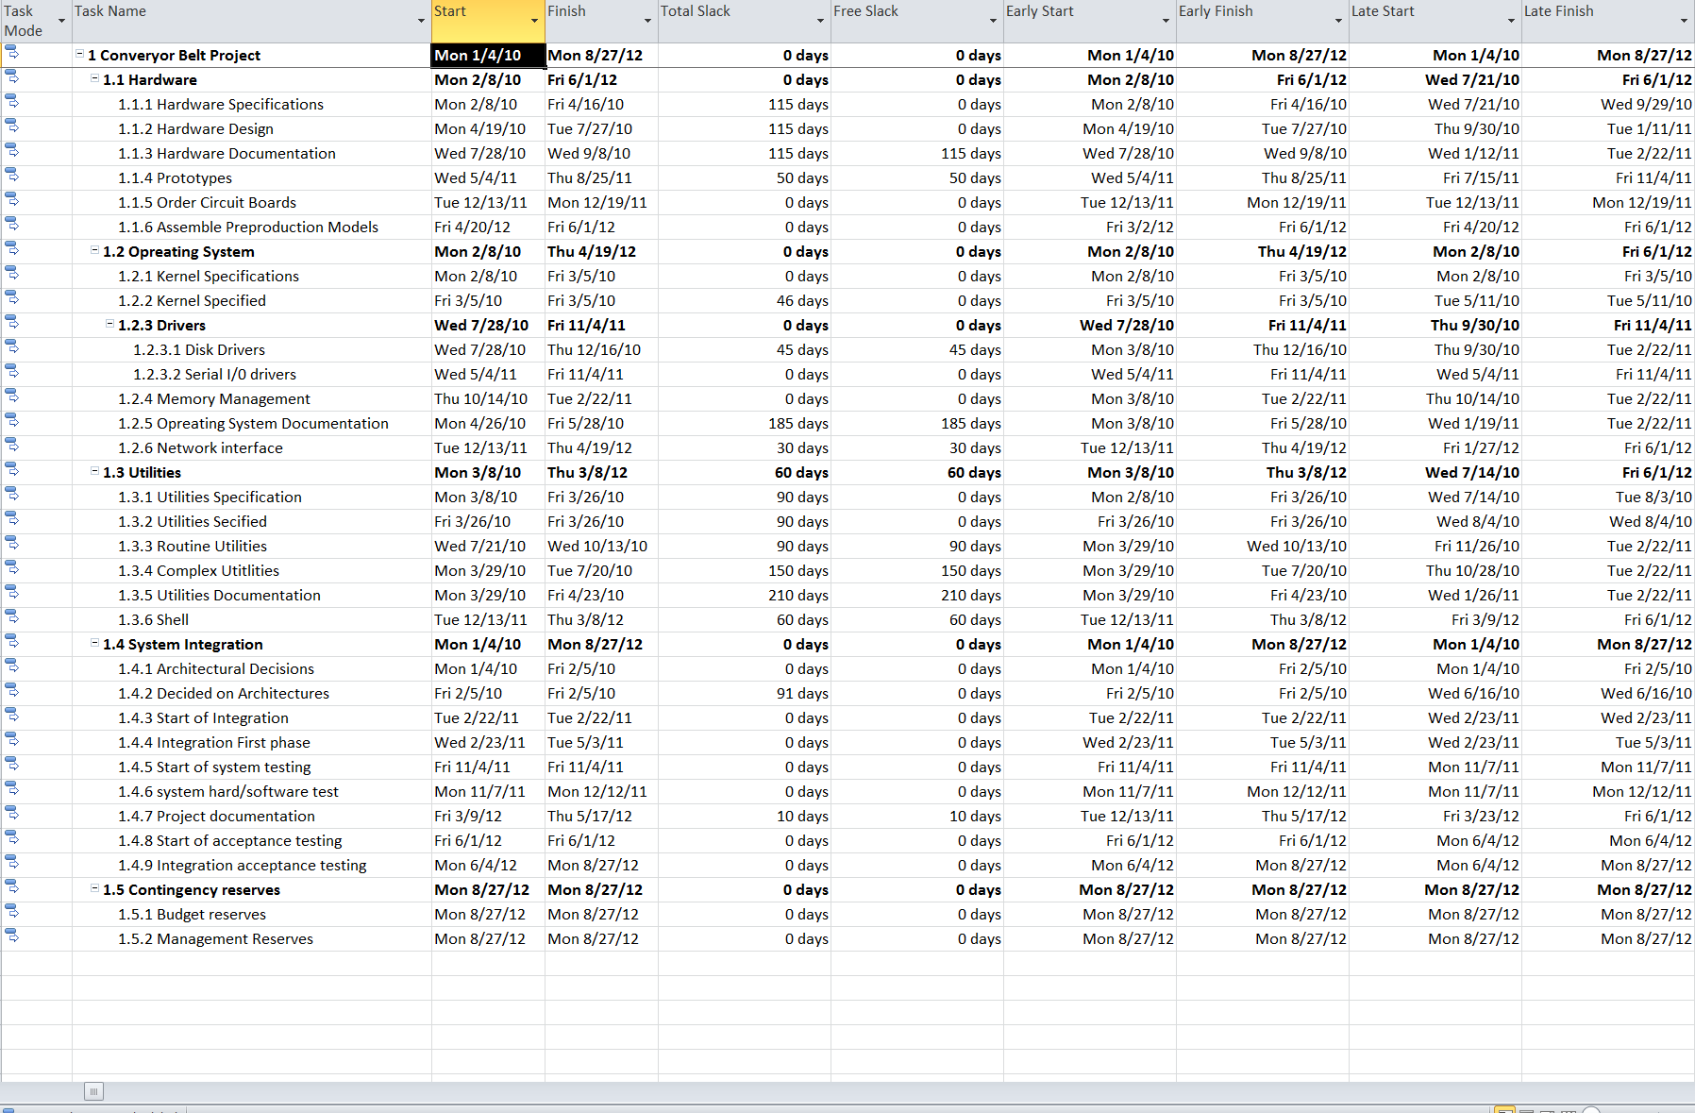

Appendix H

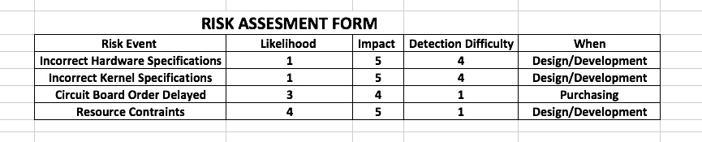

**RISK RESPONSE MATRIX:**

Appendix I

**RISK RESPONSE MATRIX:**

|  |  |  |  |  |
| --- | --- | --- | --- | --- |
| **Risk Event** | **Response** | **Contingency Plan** | **Trigger** | **Who is Responsible** |
| Incorrect Hardware specifications | Mitigate: Re-do specs | Order Replacement | Not solved within 24 hours | Design/Development team |
| Incorrect kernel specifications | Mitigate: Re-do | Order Replacement | Not solved within 24 hours | Design/Development team |
| Circuit Order board delayed | Mitigate: Select Reliable Vendor | Select reliable vendor | Not solved within 48 hours | Purchasing team |
| Resource constraint | Mitigate: Hire additional teams  Transfer:  Responsibility | Increase staff support | Call from project manager | Design/Development team |

Appendix J

**NEW SCHEDULE:**

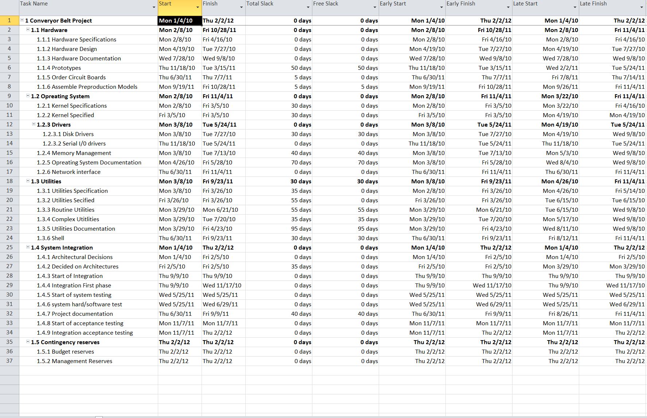

Appendix K

**GANT CHART NEW SCHEDULE:**

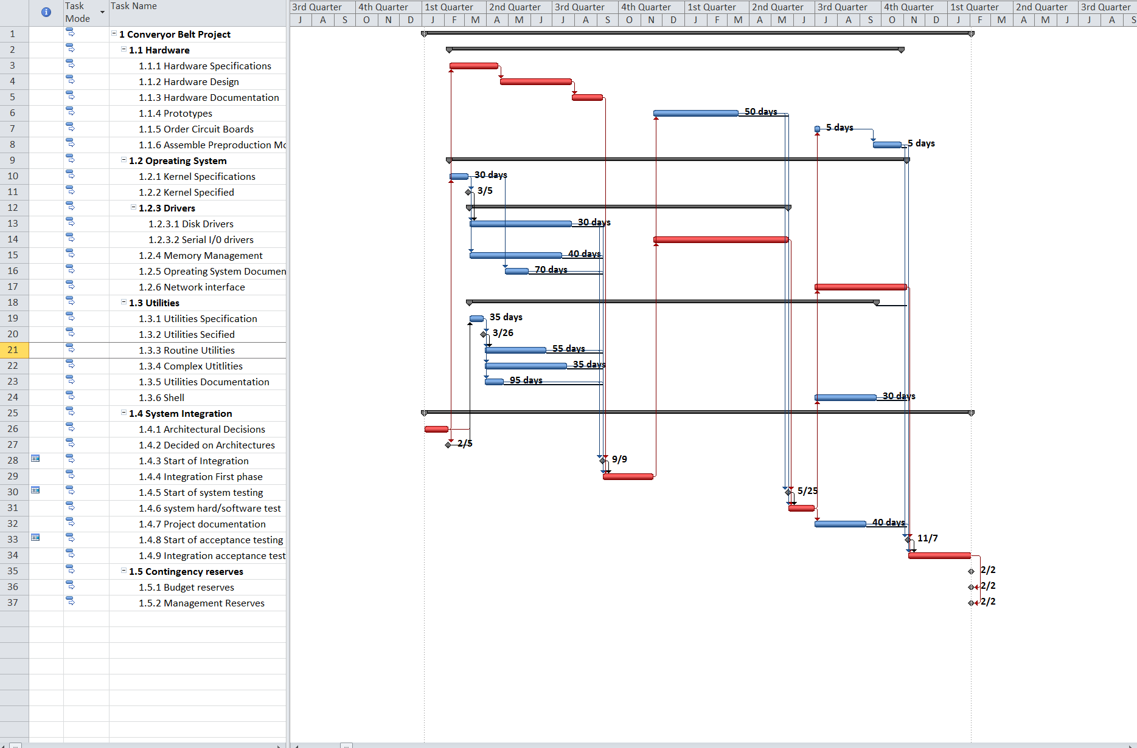

Appendix L

**RESOURCES NEW SCHEDULE:**

